FAST-NUCES Assignment # 2 Computer Modeling and Simulation

Note: Plagiarized content will be given zero marks.

1. Using the provided sharkCompetition file, which contains a model for competing species,

a. Find values for the initial populations and the constants of proportionality in which one population becomes extinct.

b. Find values for which the two populations reach equilibrium.

c. Adjust the parameters several times obtaining different results.

d. Adjust the model to have the populations constrained by carrying capacities.

e. Explain the models and discuss the results.

2. Give one set of Lotka-Volterra equations with all coefficients being different that represent a system in equilibrium, such that the number of prey is always 3000 and the number of predators is always 500.

You have to validate your working by plotting the population of prey and population of predator vs time using the code of the Lotka-Volterra model already been provided to you.

3. Write the differential or difference equations for a predator-prey model where there is a carrying capacity M for the predator.

4. Write a program representing the Romeo Juliet relationship using Lotka Volterra equations.
As discussed in the class, the following sets of equations can be used to represent the relationship.
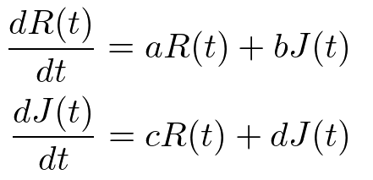

For different values of the constants a,b,c and d, the Romeo Juliet relationship evolves differently over time as you can see in the article on the link https://steemit.com/steemstem/@omstavan/love-affairs-a-mathematical-model-using-differential-equations

Your task is to represent all the scenarios discussed in the above article by giving different values to the constants and then plotting
a. The feelings for Romeo and Juliet vs time for each scenario.
b. The feelings of Romeo vs feelings of Juliet for each scenario (Such plots are already provided in the article which you can use to validate your plots.)

